**Week 3: Introduction to Networking, Firewall, and Virtualization**

**Part 1: Computer Networking**

* **TCP/IP Model:**

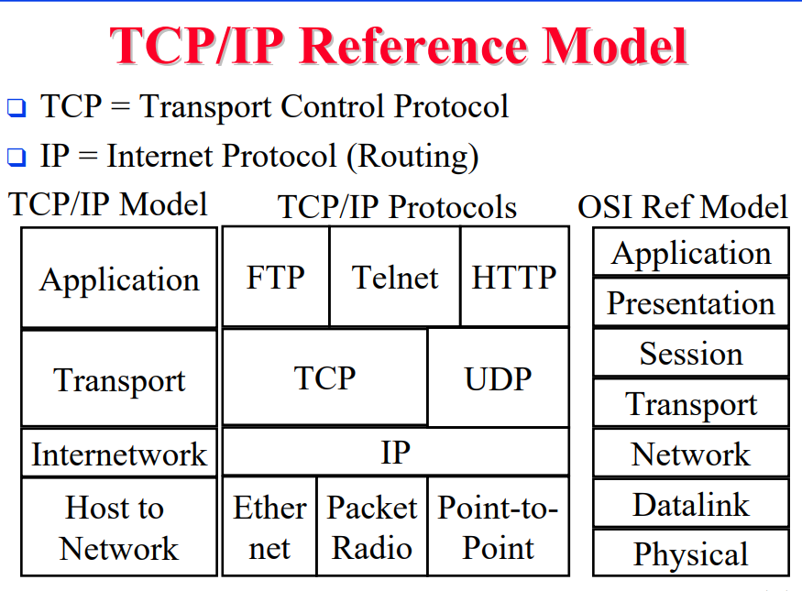

In computer networking, there are two model being used: OSI and TCP/IP model. OSI model consist of 7 layers. The model was developed for academic and research purposes, hence, it was never used. TCP/IP model is introduced to replicate the OSI model and was adopted as a global protocol for networking ever sense.

TCP\IP model consist of 5 architecture layers; the first layer is the application layer which runs application protocols such as HTTP (for web browsing) and FTP (for file exchange).

Second layer is the transport protocol which runs 2 main protocols namely TCP and UDP.

Third layer is the IP layer or the network layer where it handles the IP addresses and append necessary information for the packet to arrive successfully to the destination.

Last layer is the physical layer or what they call the Ethernet layer. This layer deals with the physical communication between the source and the destination by utilizing the communication technology such as Coaxial cables or Fiber optics.

You need to understand the first 4 layers in order to become a professional in network security. In this tutorial, we will walk you through basic information to help you understand this TCP\IP architecture.

